1. **You have decided to form a new​ start-up company developing applications for the iPhone. Give examples of the three distinct types of financial decisions you will need to make.**

* Determining which type of iPhone application projects will offer your company a positive net present​ value, and therefore are the types of projects your company should develop. This is **an investment decision.**
* Determining how to fund your iPhone application investments and what mix of debt and equity your company will have. This is **a financial decision.**
* Ensuring that your company has the necessary funds to make​ investments, pay interest on​ loans, and pay your employees. This is **a cash management decision.**

1. **Corporate managers work for the owners of the corporation.​ Consequently, they should make decisions that are in the interests of the​ owners, rather than their own. What strategies are available to shareholders to help ensure that managers are motivated to act this​ way? Shareholders can do the​ following:**
2. Ensure that employees are paid a percentage of the​ company's net income.
3. Write contracts that ensure that the interests of the managers and shareholders are closely aligned.
4. Mount hostile takeovers.
5. Ensure that employees are paid with company stock​ and/or stock options.
6. Ensure that underperforming managers are fired.
7. **Suppose you are considering renting an apartment.​ You, the​ renter, can be viewed as an agent while the company that owns the apartment can be viewed as the principal. What​ principal-agent conflicts do you​ anticipate? Suppose,​ instead, that you work for the apartment company. What features would you put into the lease agreement that would give the renter incentives to take good care of the​ apartment?**

The agent (renter) will not take the same care of the apartment as the principle (owner), because the renter does not share in the costs of fixing damage to the apartment. To mitigate this problem, having the renter pay a deposit should motivate the renter to keep damages to a minimum. The deposit forces the renter to share in the costs of fixing any problems that are caused by the renter. In addition, the provision in the lease for annual renewals allows an incentive for a long-term renter to maintain the leased apartment.

1. **Explain how the​ bid-ask spread is determined in most markets today.**
2. The​ bid-ask spread of a stock is determined by the outstanding limit orders.
3. The limit buy order with the highest price is the bid price.
4. The limit sell order with the highest price is the bid price.
5. The limit buy order with the lowest price is the ask price.
6. The limit sell order with the lowest price is the ask price.
7. **Suppose the following orders are received by an exchange for AT&T ​stock:**

* **Limit​ Order: Buy 200 shares at ​$25.15**
* **Limit​ Order: Sell 200 shares at ​$25.80**
* **Limit​ Order: Sell 100 shares at ​$25.55**
* **Limit​ Order: Buy 100 shares at ​$25.30**

1. **What are the best bid and ask prices for AT&T ​stock?**
2. The best bid price​ is: Limit​ Order: Sell 100 shares at ​$25.55​; while the best ask price​ is: Limit​ Order: Buy 100 shares at ​$25.30.
3. The best bid price​ is: Limit​ Order: Buy 200 shares at ​$25.15​; while the best ask price​ is: Limit​ Order: Sell 100 shares at ​$25.55.
4. The best bid price​ is: Limit​ Order: Buy 100 shares at ​$25.30​; while the best ask price​ is: Limit​ Order: Sell 100 shares at ​$25.55.
5. The best bid price​ is: Limit​ Order: Buy 100 shares at ​$25.30​; while the best ask price​ is: Limit​ Order: Sell 200 shares at ​$25.80.
6. **What is the current​ bid-ask spread for AT&T ​stock?** ($0.25)
7. **Suppose a market order arrives to buy 200 shares of AT&T. What average price will the buyer​ pay?** ($25.675)
8. **After the market order in ​(c​) ​clears, what are the new best bid and ask​ prices, and what is the new​ bid-ask spread for AT&T​?**
9. The best bid price​ is: Limit​ Order: Buy 200 shares at ​$25.15​; while the best ask price​ is: Limit​ Order: Sell 100 shares at ​$25.80. The new​ bid-ask spread is ​$0.25.
10. The best bid price​ is: Limit​ Order: Buy 100 shares at ​$25.30​; while the best ask price​ is: Limit​ Order: Sell 100 shares at ​$25.80. The new​ bid-ask spread is ​$0.50.
11. The best bid price​ is: Limit​ Order: Buy 100 shares at ​$25.30​; while the best ask price​ is: Limit​ Order: Sell 100 shares at ​$25.55. The new​ bid-ask spread is ​$0.25.
12. The best bid price​ is: Limit​ Order: Sell 100 shares at ​$25.80​; while the best ask price​ is: Limit​ Order: Buy 100 shares at ​$25.30. The new​ bid-ask spread is ​$0.50.
13. **Honda Motor Company is considering offering a ​$3,000 rebate on its​ minivan, lowering the​ vehicle's price from ​$33,000 to $ 30,000. The marketing group estimates that this rebate will increase sales over the next year from 38,000 to 56,000 vehicles. Suppose Honda​'s profit margin with the rebate is ​$6,300 per vehicle. If the change in sales is the only consequence of this​ decision, what are its benefits and​ costs? Is it a good​ idea?**

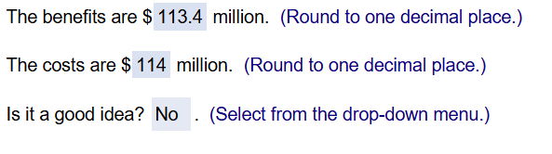

1. **You are an international shrimp trader. A food producer in the Czech Republic offers to pay you 1.8 million Czech koruna today in exchange for a​ year's supply of frozen shrimp. Your Thai supplier will provide you with the same supply for 2.3 million Thai baht today. If the current competitive market exchange rates are 28.98 koruna per dollar and 38.92 baht per​ dollar, what is the value of this​ deal?**

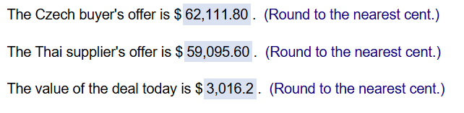

1. **You have an investment opportunity in Japan. It requires an investment of ​$0.99 million today and will produce a cash flow of yen 119 million in one year with no risk. Suppose the​ risk-free interest rate in the United States is 4.7 %​, the​ risk-free interest rate in Japan is 2.9 %​, and the current competitive exchange rate is yen 110 per dollar. What is the NPV of this​ investment? Is it a good​ opportunity?**

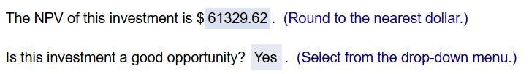

1. **You run a construction firm. You have just won a contract to build a government office building. It will take one year to construct​ it, requiring an investment of ​$10.42 million today and ​$5.38 million in one year. The government will pay you $ 19.53 million upon the​ building's completion. Suppose the cash flows and their times of payment are​ certain, and the​ risk-free interest rate is 7 %.**

**a. What is the NPV of this​ opportunity?**

**b. How can your firm turn this NPV into cash​ today?**

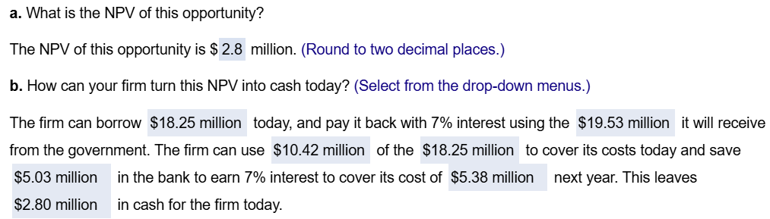

1. **Suppose Bank One offers a​ risk-free interest rate of 6.0 % on both savings and​ loans, and Bank Enn offers a​ risk-free interest rate of 6.5 % on both savings and loans.**
2. **What arbitrage opportunity is​ available?**
3. **Take a loan from Bank Enn at 6.5 % and save the money in Bank One at 6.0 %.**
4. **Take a loan from Bank One at 6.0 % and save the money in Bank Enn at 6.5 %.**
5. **Take a loan from Bank One at 6.5 % and save the money in Bank One at 6.0 %.**
6. **Save at both banks.**
7. **Which bank would experience a surge in demand for​ loans? Which bank would receive a surge in​ deposits?**
8. **Bank One would experience a surge in the demand for​ loans, as will Bank Enn.**
9. **Bank One would experience a surge in the demand for​ loans, while Bank Enn would receive a surge in deposits.**
10. **Bank One would experience a surge in the demand for​ deposits, as will Bank Enn.**
11. **Bank One would experience a surge in​ deposits, while Bank Enn would receive a surge in loans.**
12. **What would you expect to happen to the interest rates the two banks are​ offering?**
13. **Bank One would increase its loan​ rate, and/or Bank Enn would decrease its savings rate.**
14. **Both banks would decrease their interest rates.**
15. **Bank One would decrease their interest​ rates, and Bank Enn would increase its rates.**
16. **Both banks would increase their interest rates.**
17. **An​ Exchange-Traded Fund​ (ETF) is a security that represents a portfolio of individual stocks. Consider an ETF for which each share represents a portfolio of 1 share of Hewlett dash Packard ​(HPQ​), 3 shares of Sears ​(SHLD​), and 4 shares of General Electric ​(GE​). Suppose the current stock prices of each individual stock are as shown​ here:**

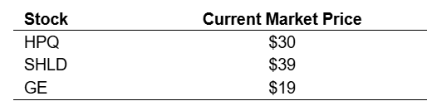

1. **What is the price per share of the ETF in a normal​ market?**



1. **If the ETF currently trades for ​$205​, what arbitrage opportunity is​ available? What trades would you​ make? (Ignore any transaction​ costs.)**
2. **Buy 1 share of HPQ and 3 shares of SHLD. Sell a share of the ETF and two shares of GE.**
3. **Buy 1 share of HPQ​, 3 shares of SHLD​, and 4 shares of GE​, and sell one share of the ETF.**
4. **Buy one share of the ETF and sell 1 share of HPQ​, 3 shares of SHLD​, and 4 shares of GE.**
5. **Although an arbitrage opportunity​ exists, it is impossible based on the information to tell how to construct it.**
6. **If the ETF currently trades for ​$205​, what arbitrage opportunity is​ available? What trades would you​ make? (Ignore any transaction​ costs.)**
7. **Sell four shares of HPQ​, two shares of SHLD and six shares of GE and buy two shares of the ETF.**
8. **Buy 1 share of HPQ and 3 shares of SHLD. Sell a share of the ETF and a share of GE.**
9. **Buy 1 share of HPQ​, 3 shares of SHLD​, and 4 shares of GE​, and sell one share of the ETF.**
10. **Although an arbitrage opportunity​ exists, it is impossible based on the information to tell how to construct it.**
11. **The Xia Corporation is a company whose sole assets are ​$100,000 in cash and three projects that it will undertake. The projects are​ risk-free and have the following cash​ flows:**

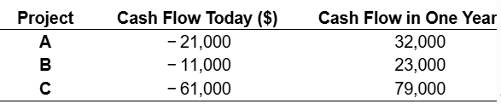

**Xia plans to invest any unused cash today at the​ risk-free interest rate of 8 %. In one​ year, all cash will be paid to investors and the company will be shut down.**

1. **What is the NPV of each​ project? Which projects should Xia undertake and how much cash should it​ retain?**

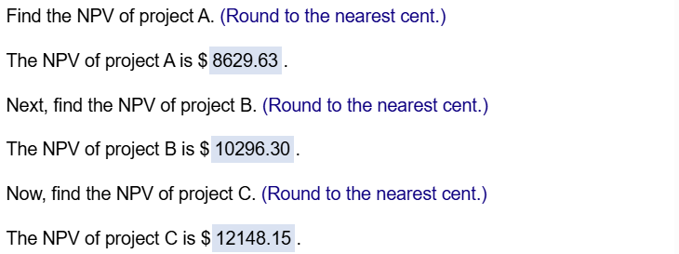

**Which projects should Xia undertake and how much cash should it​ retain?**

1. **Projects B and C have positive​ NPV, and Xia has enough​ cash, so Xia should take them.**
2. **All projects have positive​ NPV, and Xia has enough​ cash, so Xia should take all of them.**
3. **Projects A and B have positive​ NPV, and Xia has enough​ cash, so Xia should take them.**
4. **Projects A and C have positive​ NPV, and Xia has enough​ cash, so Xia should take them.**
5. **What is the total value of Xia​'s assets​ (projects and​ cash) today?**



1. **What cash flows will the investors in Xia ​receive? Based on these cash​ flows, what is the value of Xia ​today?**

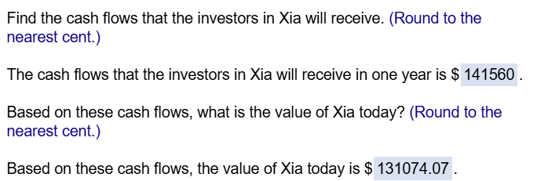

1. **Suppose Xia pays any unused cash to investors​ today, rather than investing it. What are the cash flows to investors in this​ case? Based on these cash​ flows, what is the value of Xia ​today?**

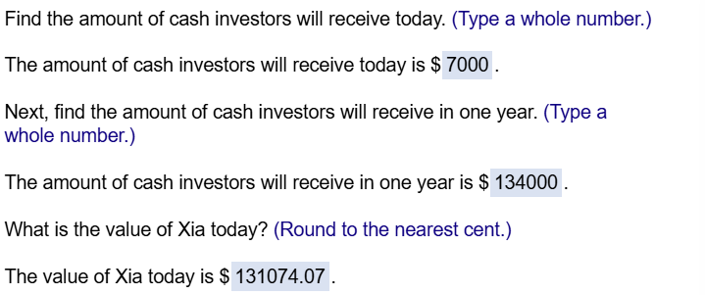

1. **Explain the relationship in your answers to parts ​(b​), ​(c​), and ​(d​).**
2. **Results from ​(b​), ​(c​), and ​(d​) are the same because all methods value Xia​'s assets today.**
3. **Whether Xia pays out cash now or invests it at the​ risk-free rate, investors get the same value today.**
4. **The point is that a firm cannot increase its value by doing what investors can do by themselves​ (and is the essence of the separation​ principle).**
5. **The point is that a firm can increase its value by more efficiently doing what investors can do by themselves​ (and is the essence of the separation​ principle).**
6. **Consider a portfolio of two​ securities: one share of Johnson and Johnson​ (JNJ) stock and a bond that pays ​$100.00 in one year. Suppose this portfolio is currently trading with a bid price of ​$211.69 and an ask price of ​$212.26​, and the bond is trading with a bid price of ​$91.74 and an ask price of ​$91.91. In this​ case, what is the​ no-arbitrage price range for JNJ​ stock?**
7. **According to the Law of One​ Price, the price that the portfolio of securities is trading is equal to the sum of the price of securities within the portfolio. If the​ portfolio, composed of a bond and JNJ stock is currently trading with a bid price of ​$211.69 and an ask price of ​$212.26​, and the bond is trading at a bid price of ​$91.74 and an ask price of ​$91.91​, then the​ no-arbitrage price of the stock should be between $ 211.69 minus $ 91.91 equals $ 119.78 and $ 212.26 minus $ 91.74 equals $ 120.52.**
8. **According to the Law of One​ Price, the price that the portfolio of securities is trading is equal to the sum of the price of securities within the portfolio. If the​ portfolio, composed of a bond and JNJ stock is currently trading with a bid price of ​$211.69 and an ask price of ​$212.26​, and the bond is trading at a bid price of ​$91.74 and an ask price of ​$91.91​, then the​ no-arbitrage price of the stock should be between $ 211.69 minus $ 91.74 equals $ 119.95 and $ 212.26 minus $ 91.91 equals $ 120.35.**
9. **At any price below ​$119.78 or above ​$120.52 an arbitrage opportunity would exist. For​ example, if the stock were currently trading at ​$119.09​, an investor could purchase the stock and the bond for $ 119.09 plus $ 91.91 equals $ 211.00 and then immediately sell the portfolio for ​$211.69 and have an arbitrage of $ 211.69 minus $ 211.00 equals $ 0.69. If the price of the stock was ​$120.63​, then an investor could purchase the portfolio for ​$212.26 and sell the bond and stock individually for ​$91.74 and ​$120.63 respectively. The investor would gain an arbitrage of $ 91.74 plus $ 120.63 minus $ 212.26 equals $ 0.11.**
10. **At any price below ​$120.35 or above ​$119.95 an arbitrage opportunity would exist. For​ example, if the stock were currently trading at ​$119.09​, an investor could purchase the stock and the bond for $ 119.09 plus $ 91.91 equals $ 211.00 and then immediately sell the portfolio for ​$211.69 and have an arbitrage of $ 211.69 minus $ 211.00 equals $ 0.69. If the price of the stock was ​$120.63​, then an investor could purchase the portfolio for ​$212.26 and sell the bond and stock individually for ​$91.74 and ​$120.63 respectively. The investor would gain an arbitrage of $ 91.74 plus $ 120.63 minus $ 212.26 equals $ 0.11.**
11. **Suppose the current market price of corn is ​$3.55 per bushel. Your firm has a technology that can convert 1 bushel of corn to 3 gallons of ethanol. If the cost of conversion is ​$1.53 per​ bushel, at what market price of ethanol does conversion become​ attractive?**



1. **Suppose your employer offers you a choice between a ​$6,400 bonus and 300 shares of the company stock. Whichever one you choose will be awarded today. The stock is currently trading for ​$63 per share. Ignore transaction costs.**
2. **Suppose that if you receive the stock​ bonus, you are free to trade it. Which form of the bonus should you​ choose? What is its​ value?**

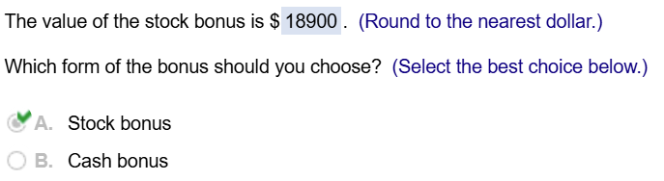

1. **Suppose that if you receive the stock​ bonus, you are required to hold it for at least one year. What can you say about the value of the stock bonus​ now?**
2. **The stock bonus is worth more than its value calculated in part ​(a​), so you still prefer the stock bonus.**
3. **The stock bonus cannot be worth more than the value calculated in part ​(a​), so you prefer the cash bonus.**
4. **You cannot make a definitive decision but the stock bonus is not likely worth as much as the value calculated in part ​(a​).**
5. **The answer is the same as part ​(a​).**

**What will your decision depend​ on?**

1. **Your decision should be based on the type of bonus your employer prefers.**
2. **You should consider the​ stock's potential value in one year along with the risk involved.**
3. **Your decision should be based on the market value of the stock today.**
4. **Your decision should be based on how well your​ company's stock has done over the past year.**